Unit One Assignment: SOIL LAB: Perform Your Soil Test

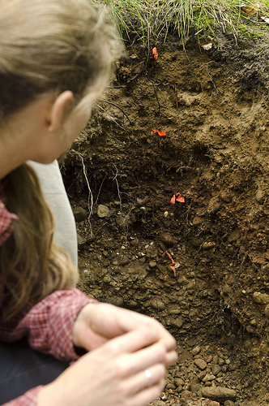
This assignment has two parts. Part one is to complete your own soil test. After viewing the video “Collecting Soil Samples: From the Ground Up” and Power Point presentation “Introduction to Soil Types, Structures and Pasture Management” complete your own soil test and submit your sample to your own area extension center.

Before you begin you should call your local extension center for current fees and services information and request an interpretation of your soil test results. Be sure to inquire about what types of soil samples your lab accepts. Some labs may not take agriculture pasture samples but take regular backyard or garden samples. Depending on your particular soil sample you need to find a lab to suit your needs and location.

Also find out testing costs and how long it will take to get your sample results. Often labs will provide sample bags for you before you take your soil test if you call to request sampling information. Then you are ready to take your soil sample. You may sample soil from your own farm, a farm you have access to or even your own back yard.

For part two of the assignment write a report of your process and findings. Then submit to the Dropbox. Be sure to include the following information in your report:

- The name of the location where you took your soil sample.
- The name and address of your local extension center.
- Current fees and services they offer
- Sampling services they offer
- How long it will take to get your soil sample interpretation results

This assignment is worth 25 points.

(Please Note: You will be using your soil test results for your final project in this class so keep track of them once you receive them back from your lab!)

