Course Title: Pasture Management |  |  | Developer: James Donaldson
Date: 10/1/13 | Course Number:  SLF 150 | Term Course Launches:  Spring 2014 | School:  John Wood CC
Pasture Management
Course overview here: This course introduces students to principles and practices of pasture management. Topics include soil management practices, forage crop growth, and forage quality for common types of livestock. Focus is on small scale production for niche markets. Upon completion, students will have the knowledge and skills to develop a pasture management plan to sustainably produce high quality forage.

Course  Image: | 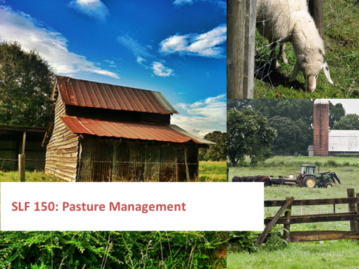
Image  Attribution | 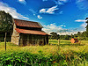  “Barn and Hayfeeder” by GA-Kayaker CC BY 2.0  http://www.flickr.com/photos/ga-kayaker/9356600221/  Barn Hayfeeder.jpeg  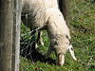  “Grazing sheep” by Mihnea Stanciu CC BY 2.0  http://www.flickr.com/photos/fallout/3114411996/  SheepFence.jpeg  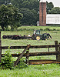  “20130712-AMS-LSC-0330.jpg” by U.S. Department of Agriculture CC BY 2.0  http://www.flickr.com/photos/usdagov/9305896234/  TractorFence.jpeg
Course  Outcomes | By the end of this course, you should be able to:  - Perform a soil test.  - Analyze soil test results.  - Determine fertilizer and amendment rates in response to soil test results.  - Identify appropriate timing of fertilizer and amendment applications.  - Describe pasture management and use patterns which damage soil quality.  - Identify forage species common in Midwest pasture.  - Describe the role of legumes in maintaining soil fertility.  - Select appropriate forage species for particular livestock types.  - Estimate dry matter yield of the forage species and mixed pasture types studied.  - Differentiate between perennial and annual forage species.  - Describe growth patterns of forage species.  - Identify weed species common to Midwest pastureland.  - Identify weed management strategies.  - Evaluate the duration that a given pasture should be grazed based on environmental conditions and stocking rate.  - Determine the appropriate stocking rate, given the size of the pasture and type of livestock.  - Formulate seed mixes for pasture.  - Identify tools and equipment used for pasture management.  - Describe all appropriate methods of planting and establishing the forage species studied.  - Identify appropriate timing for seeding the forage species studied.  - Identify appropriate seed rates for the forage species studied.  - Develop a grazing rotation for a real or hypothetical pasture-based livestock operation.  - Develop a comprehensive pasture management plan for a real or hypothetical pasture-based livestock operation.
Syllabus | Below is the course syllabus that outlines our 8 week course as well as describes the course goals, expectations and grading system. Please print a copy to refer to throughout the course term.
Links/Uploads | SLF 150_PastureMgmt_Syllabus.doc
Grading | Points Summary Points %  Assignments (25 pts each) 200 40%  Discussion Board (15 pts each) 105 21%  Quizzes (10 pts each) 70 14%  Final Project (150 pts) 125 25%  Total 500 100%  The final letter grade will be determined according to the following scale:  Scale: A 90-100%  B 80-89%  C 70-79%  D 60-69%  F ……59% and below
Links/Uploads
Instructor Contact Information | Instructor:  Email:  Telephone:  Skype #:  Availability:  To access the Virtual Office, click on the link in the left hand content window at the time of your appointment
Course Materials | Open access websites will be used as well as online materials posted by the instructor.
Home Page  Announcements | Welcome Message:  Welcome to SLF 150 Pasture Management! In this class we will be learning about different principles and practices of pasture management including topics like soil management, forage growth and quality, pasture stocking rates, calculating yield and pasture equipment and maintenance. This class was designed to help introduce you to best practices in pasture management so that you can decide which ones might work best for you.  As class begins, you should become familiar with the course syllabus as it describes the class in full detail and informs you of other course requirements and materials you need to complete the course. Also remember to login to the class consistently to stay up-to-date on any news and information that may be posted by the instructor.  Please Note: Instead of a final class exam you will be required to complete a final project for this class. More information on the project and what you will need to prepare will be given during our live lecture during week two of this class. Attendance to that lecture is very important! Please plan accordingly.  Once again, welcome to the class! I look forward to working with all of you.
General Class Discussion Board | This discussion board is for you to post any questions you might have concerning general course content or to post resources and information you find that you want to share with the rest of the class.  Remember to keep the content you post with the theme of the class! Do not post jokes or pictures that you might post on a Facebook page. This area is to post helpful resources you might see that you think will help your fellow classmates with their future agriculture goals.  Also remember this is a discussion board that everyone can see! If you have a question regarding grades or have specific questions regarding one of your personal assignments it is best not to post that question here but rather contact the instructor personally with your questions.

Unit 1
Title | Introduction to Soil Types and Structure
Landing Page  Image | 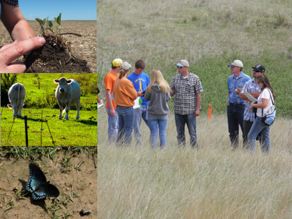  Unit One Landing.png
Image/Image  Attribution | 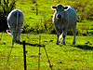  “Cows” by Lee Cannon CC BY-SA 2.0  http://www.flickr.com/photos/leecannon/5035124764/  Grazing Green.jpeg  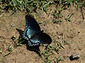  “Red-spotted Purple-Limenitis arthemis astyanax by Topato CC BY 2.0  http://www.flickr.com/photos/roadhunter/2646211457/  Butterfly on Loam Soil.jpeg  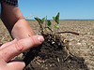  “Healthy Soil 3” by USDA NRCS South Dakota CCBY-SA 2.0  http://www.flickr.com/photos/nrcs_south_dakota/7166253549/  Happy Soil.jpeg  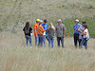  “Soil Days at Philip, SD June 2012” by USDA NRCS South Dakota CC BY-SA 2.0  http://www.flickr.com/photos/nrcs_south_dakota/7882759646/  Pasture Group.jpeg
Content  Overview | In this unit you will learn about the soil testing process, understand the different types of soil and soil structures and analyze what pasture management means to you.
Objectives | In this unit you should:  - Perform a soil test.  - Describe pasture management and use patterns which damage soil quality
Outcomes | - Understand steps and process of soil testing.  - Identify different types of soil.  - Identify different soil structures.  - Describe pasture management.  - Learn patterns which damage soil quality.
To-Do-List | - View the Power Point: “Introduction to Soil Types, Structure and Pasture Management”  - Watch the short video “Collecting Soil Samples: From the Ground Up”  - Complete the Discussion Board “What is Pasture Management to You?” (15pts)  - Complete the Dropbox Assignment: “SOIL LAB: Perform Your Soil Test” (Part One and Part Two) (25 pts)  - Take the Quiz over the readings (10 pts)
Links/Uploads | SLF 125_Unit One Instructions.doc
Unit 1 Activities
Power Point | “Introduction to Soil Types, Structure and Pasture Management”
Content | View the Power Point “Introduction to Soil Types, Structure and Pasture Management”
Links/Uploads | Unit One Power Point.pptx
Content Atributions | - Boundless.com – Biology- Chapter 46 Plant Nutrition- (section 2) Soil Ecosystem – “Lignin to Humus”  - Boundless.com – Biology – Chapter 46 Plant Nutrition- (section 2) Soil Ecosystem – “Role of Soil Conservation in Sustainable Agriculture”  - Boundless.com – Biology – Chapter 46 Plant Nutrition- (section 2) Soil Ecosystem – “Texture of Soil”  - Boundless.com – Biology – Chapter 46 Plant Nutrition- (section 2) Soil Ecosystem – “Organic Components of Soil”  - Jim Donaldson, course developer
Image/Image Attributions | 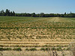  “Harvested Grass Seed field” by born1945 CC BY 2.0 http://www.flickr.com/photos/12567713@N00/227607861/  Harvested Grass Field.jpeg  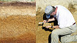  “Soil Scientist at Work (4)” BY Soil Science CC BY 2.0 http://www.flickr.com/photos/soilscience/5094929872/  Soil Horizon.jpeg  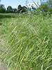  “Managed Meadow (Annually mowed in spring) at Cherokee Park” by mightyjoepye CC BY 2.0 http://www.flickr.com/photos/mightyjoepye/3995160332/  Cheat Brome and Orchard Grass.jpeg  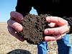  “Soil Pores In Healthy Soil” by NRCS Soil Health CC BY 2.0  http://www.flickr.com/photos/87743206@N04/8053617246/Healthy Soil.jpeg  Healthy Soil.jpeg  “Soil Centipede” by Matt Reinbold CC BY-SA 2.0  http://www.flickr.com/photos/furryscalyman/2092230152/  Soil Centipede.jpeg  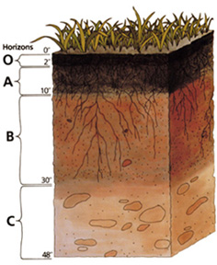  “soil-profile” Boundless.com – Biology – Chapter 46 Plant Nutrition- (section 2) Soil Ecosystem – “Texture of Soil” http://commons.wikimedia.org/wiki/File:Soil_profile.png  soil-profile.png  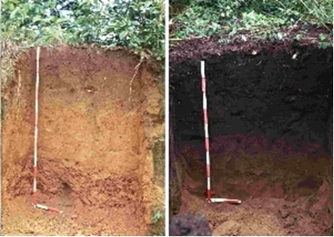  “tera-pera” Boundless.com – Biology – Chapter 46 Plant Nutrition- (section 2) Soil Ecosystem – “Organic Components of Soil” http://commons.wikimedia.org/wiki/File:Terra_Preta.jpg  terra-preta.jpeg  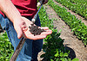  “Soybean Field with Healthy Soil” by USDA NRCS South Dakota CC BY-SA 2.0  http://www.flickr.com/photos/nrcs_south_dakota/9316804120/  Soil Tube.jpeg  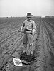  “Soil Testing” by Texas A&M Cushing Memorial Library and Archives CC BY 2.0  http://www.flickr.com/photos/cushinglibrary/3657263606/  Soil Testing.jpeg  “Tommy Soil Pressure Test No Till2 LR” by U.S. Department of Agriculture (USDA) CC BY 2.0  http://www.flickr.com/photos/usdagov/8465155025/  NoTill Soil Test.jpeg
Video | “Collecting Soil Samples: From the Ground Up”
Content | Watch the video “Collecting Soil Samples: From the Ground Up” http://www.youtube.com/watch?v=3he8yFg7YX8 .This video will show you a simple method of collecting a soil sample.
Content Attribution | University of Wyoming Extension  Horticulture. Produced by: David Keto - Extension Media Producer Creative Commons Attribution license (reuse allowed)
Quiz | Unit One Quiz
Content | Select the answer that best fits the question given. (worth 10 points)  - A good pasture management decision you can make is to:  - Over graze  - Encourage legumes ( correct 2 pts)  - Never fertilize  - Avoid applying lime  - Which of the following best describes soil?  - Dynamic and changing  - Weathered inorganic rock material  - Composed of mineral and organic material  - All of the above (correct 2 pts)  - It is important to match forage species traits with soil characteristics and pasture usage (true / false) (true) (2 pts)  - Soil has horizontal layers which are called:  - Horizons (correct 2 pts)  - Layers  - Subzones  - Landscapes  - Soil management becomes more successful when:  - Fertilizers are always used  - People understand which properties can be changed and which properties cannot be changed (correct 2 pts)  - Soil is left alone  - An expensive management system is put into place
Content  Attributions | James Donaldson, course developer
Discussion Board | “What is Pasture Management to You?”
Content | For this discussion board reflect on what you have read for this week and formulate your own personal definition of pasture management. Then think about what it means to you and your personal ambitions in farming. Post your definition, views on pasture management and how you think it will apply to your present/future farming operation to the discussion board. This post is worth (15 points).
Dropbox Assignment | SOIL LAB: Perform Your Soil Test (Part One and Part Two)
Image | 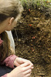
Image Attribution | “Soil Ecology Course” by University of Michigan School of Natural Resources and Environment CC By 2.0  http://www.flickr.com/photos/snre/10059246656/  Soil Gazing.jpeg
Content | This assignment has two parts. Part one is to complete your own soil test. After viewing the video “Collecting Soil Samples; From the Ground Up” and viewing the Power Point “Introduction to Soil Types, Structure and Pasture Management” complete your own soil test and submit your sample to your own area extension center.  Before you begin you should call your local extension center for current fees and services information and request an interpretation of your soil test results. Be sure to inquire about what types of soil samples your lab accepts. Some labs may not take agriculture pasture samples but take regular backyard or garden samples. Depending on your particular soil sample you need to find a lab to suit your needs and location. Also find out testing costs and how long it will take to get your sample results. Often labs will provide sample bags for you before you take your soil test if you call to request sampling information. Then you are ready to take your soil sample. You may sample soil from your own farm, a farm you have access to or even your own back yard.  For part two of the assignment write a report of your process and findings. Then submit to the Dropbox. Be sure to include the following information in your report:  - The name of the location where you took your soil sample.  - The name and address of your local extension center.  - Current fees and services they offer  - Sampling services they offer  - How long it will take to get your soil sample interpretation results  This assignment is worth 25 points.  (Please Note: You will be using your soil test results for your final project in this class so keep track of them once you receive them back from your lab!)
Content  Attribution | James Donaldson, course developer
Links/Uploads | Unit One Assignment.pdf
Announcements

Unit 2
Title | Soil Fertility
Landing Page  Image | 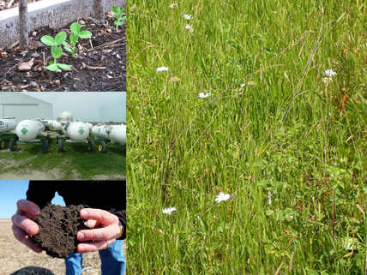  Unit Two Landing.png
Image/Image  Attribution | 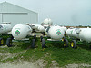  “Fertilizer” by Thirteen of Clubs CC BY-SA 2.0  http://www.flickr.com/photos/thirteenofclubs/4617875064/  Fertilizer.jpeg  “Soil Pores In Healthy Soil” by NRCS Soil Health CC BY 2.0  http://www.flickr.com/photos/87743206@N04/8053617246/  Healthy Soil.jpeg  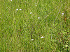  “Schedonorus pratensis” by Matt Levin CC BY-SA 2.0  http://www.flickr.com/photos/plant_diversity/3821064072/  Grass Mix.jpeg  “Fertilizer” by Thirteen of Clubs CC BY-SA 2.0  http://www.flickr.com/photos/thirteenofclubs/4617875064/  Fertilizer.jpeg
Content  Overview | In this unit you will learn how to read and understand a soil test report, determine appropriate timing and application for fertilizers as well as understand the importance of legumes in maintaining the soil.
Objectives | In this unit you should:  - Analyze soil test results  - Determine fertilizer and amendment rates in response to soil test results.  - Identify appropriate timing of fertilizer and amendment applications.  - Describe the role of legumes in maintaining soil fertility.
Outcomes | - Understand soil test results and fertilizer/amendment rates in response to soil test results.  - Learn appropriate timing and application of fertilizer and amendments.  - Know the role of legumes in maintaining soil.
To-Do-List | - View the Power Point: “Interpreting Soil Tests, Applying Fertilizer and Role of Legumes in Soil Maintenance”  - Watch the video: “Soil Health Study: Grazing Management and Infiltration”  - Attend Live Seminar  - Complete the Discussion Board “Loving Legumes” (15pts)  - Complete the Dropbox Assignment “Decoding the Soil Test” (25 pts)  - Take the Quiz over the readings (10 pts)
Links/Uploads | SLF 125_Unit Two Instructions.pdf
Unit 2 Activities
Power Point | “Interpreting Soil Tests, Applying Fertilizer and Role of Legumes in Soil Maintenance”
Content | View the power point content “Interpreting Soil Tests, Applying Fertilizer and Role of Legumes in Soil Maintenance”
Links/Uploads | Unit Two Power Point.pptx
Content Attribution | James Donaldson, course developer  Boundless.com – Biology – Chapter 46 Plant Nutrition- (section 2) Soil Ecosystem – “Fertilization”  Boundless.com – Biology – Chapter 46 Plant Nutrition- (section 2) Soil Ecosystem – “Soil PH Adjustment”  Boundless.com – Biology – Chapter 46 Plant Nutrition- (section 2) Soil Ecosystem – “Control Soil Erosion”
Image/Image Attribution | 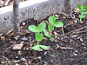  “Pea plants” by Linda N. CC BY 2.0  http://www.flickr.com/photos/22748341@N00/3478752900/  Baby Pea Plants.jpeg  “Pea plants” by Linda N. CC BY 2.0  http://www.flickr.com/photos/22748341@N00/3478752900/  Baby Pea Plants.jpeg  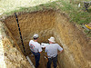  “Soil Scientists at Work (4)” by Soil Science CC BY 2.0  http://www.flickr.com/photos/soilscience/5094937726/  Soil Pit.jpeg  “Fertilizer” by Thirteen of Clubs CC BY-SA 2.0  http://www.flickr.com/photos/thirteenofclubs/4617875064/  Fertilizer.jpeg  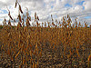  “Soybeans” by wattpublishing CC BY 2.0  http://www.flickr.com/photos/wattagnet/6726228729/  Soybeans.jpeg  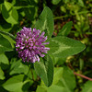  “Red Clover” by John B. CC BY 2.0  http://www.flickr.com/photos/dendroica/4672993616/  Redclover.jpeg
Video | “Soil Health Study: Grazing Management and Infiltration”
Content | View the video “Soil Health Study: Grazing Management and Infiltration” by following the link:  http://www.youtube.com/watch?v=IqB4z7lGzsg.  In this video you will see the effects of different grazing methods on soil and see how an infiltration test is done. Side by side comparisons of the soil samples are done to help you see how soil is negatively affected.
Content Attribution | “Soil Health Study: Grazing Management and Infiltration” by USDA NRCS South Dakota  Creative Commons Attribution license (reuse allowed)
Links/Uploads | http://www.youtube.com/watch?v=IqB4z7lGzsg.
Live Seminar (Big Blue Button) | “Welcome to Class and Introduction to Final Project”
Content | Purpose: Give introduction to class and overview as well as introduce final project assignment sheet. (attached as document)
Content Attribution | James Donaldson, course developer
Links/Uploads | Final Project Assignment Sheet.doc
Quiz | Unit Two Quiz
Content | Select the answer that best fits the question given. (worth 10 points)  - Soil test results can make recommendations on changing what levels in your soil?  - Oxygen  - Phosphate (correct 2 pts)  - Water  - Helium  - Timing and application of fertilizer can depend on type of forage or crop being used. (true/false)  - True (correct, 2pts)  - False  - Legumes are a group of plants including alfalfa, clover and beans that are able to convert _______________ into a form used by plants and animals?  - Oxygen  - Nitrogen (correct 2 pts)  - Crops  - Water  - Which of the following are benefits of Legumes?  - Provide excellent forage  - Help build soil nutrients  - Provide good cover  - All of the above (correct 2 pts)  - Types of Perennial Legumes are alfalfa and red clover (true/false)  - True (correct, 2 pts)  - False
Content  Attributions | Jim Donaldson, course developer
Discussion Board | “Loving Legumes”
Content | For this discussion post please answer the following questions. To get your answers you should pull from the reading for this week as well as do a little research on your own. This research could include talking to farmers in your area and an internet search on the topic. Respond to at least one classmates post by giving feedback, posing new questions about what they have written and/or offering your praise or criticisms. Be sure to go beyond simply stating things like “I like your post” or “I agree with you.” Tell why you agree or disagree.  - How do farmers in your area use legumes?  - What do you believe are some of the best uses of legumes?  - How do you see yourself using legumes on your future farm?
Dropbox Assignment | “Decoding the Soil Test”
Image
Image Attribution | “Eye-glass, Spy-glass” by Howard Lewis Ship CC BY-SA 2.0  http://www.flickr.com/photos/hlship/3107470043/  Eye Glasses.jpeg
Content | Since you do not have your own soil test results back from your assignment in Unit One, for this assignment you will study an example soil test to practice interpreting a soil test report.  (Please Note: You will be using your own soil test results for your final project in this class so keep track of them!)  To access an example soil test go to the University of Minnesota Extension site located at the following link: http://soiltest.cfans.umn.edu/understanding-your-report/agronomic-crops/ . Scroll down the page until you find the “Example Soil Test Report” and click on the underlined PDF link. Carefully read the report looking at each box and the numbered comments at the end. After you have read the report answer the questions below using the information provided on the report. Upload to the Dropbox. This exercise is to help you practice reading and understanding a soil report.  1. According to the soil test results what is the estimated soil texture for this particular soil?  2. According to the soil test results what is the PH level and Potassium level for this particular soil?  3. What low levels are comments 8 and 9 referring to?  4. What does comment 15 recommend?  5. Choose an additional comment and explain it in your own words.
Content  Attribution | James Donaldson, course developer
Links/Uploads | Unit Two Assignment.pdf
Announcements | For more information on interpreting soil test results visit the University of Arkansas Division of Agriculture Research and Extension for an in depth look at how to understand the numbers of your soil tests. LINK: http://www.uaex.edu/Other_Areas/publications/pdf/FSA-2118.pdf.  For more information on fertilizer recommendations visit the Purdue University Extension. LINK: “Tri-State Fertilizer Recommendations for Corn, Soybeans, Wheat and Alfalfa” http://www.extension.purdue.edu/extmedia/AY/AY-9-32.pdf

Unit 3
Title | Forage Species and Weeds
Landing Page  Image | 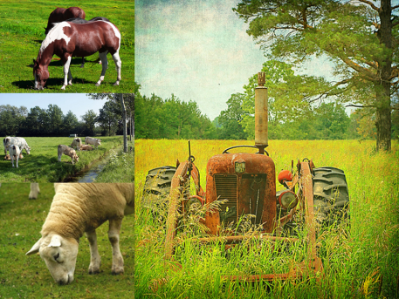  Unit Three Landing.png
Image/Image  Attribution | 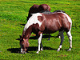  “Horses Grazing” by Rennet Stowe CC BY 2.0  http://www.flickr.com/photos/tomsaint/4840982575/  HorsesGrazing.jpeg  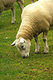  “Sheep Grazing” by Martin Pettitt CC BY 2.0  http://www.flickr.com/photos/mdpettitt/2681167650/  SheepGrazing.jpeg  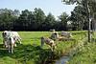  “Grazing cows/Lekker grazen by Hans Dinkelberg CC BY 2.0  http://www.flickr.com/photos/uitdragerij/2919611022/  GrazingCows.jpeg  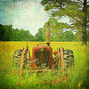  “Ol’ Lazy Eye” by Robb North CC BY 2.0  http://www.flickr.com/photos/robbn1/3735208498/  OldTractor.jpeg
Content  Overview | In this unit you will learn all about different types of forage species and weed species common to Midwest pastureland. You will identify types of grasses and weeds as well as learn weed management strategies to use on problem weeds.
Objectives | In this unit you should:  - Select appropriate forage species for particular livestock types.  - Differentiate between perennial and annual forage species.  - Describe growth patterns of forage species.  - Identify weed species common to Midwest pastureland.  - Identify weed management strategies.
Outcomes | - Understand and identify different types of plant forage species that match specific livestock.  - Explain different growth patterns of plant forage species.  - Identify weed species and appropriate management of them.
To-Do-List | - Read the article “Hay and Pasture” (pages 10 -17) (start at the end of page 10 “Selecting Hay and Pasture Species”) by Jim Morrison from the Rockford Illinois Extension Center  - View the Power Point: “Weed Identification Guide”  - Complete the Discussion Board “Crabgrass Anyone?” (15pts)  - Complete the Dropbox Assignment “Identify Your Weeds” (25 pts)  - Take the Quiz over the reading (10 pts)
Links/Uploads | SLF 125_Unit Three Instructions.doc
Unit 3 Activities
Reading One | “Establishing Forages”
Image/Image Attribution | 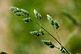  “Grass” by Andy Rogers CC BY-SA 2.0  http://www.flickr.com/photos/cobaltfish/7304720350/  Grassgrain.jpeg
Content | Read the article “Hay and Pasture” (pages 10 -17) (start at the end of page 10 “Selecting Hay and Pasture Species”) by Jim Morrison from the Rockford Illinois Extension Center http://extension.cropsci.illinois.edu/handbook/pdfs/chapter06.pdf  This reading gives a detailed look at selecting and establishing pasture grasses and legumes.  - Identify forage strengths and weaknesses  - As you choose your forage species how can you evaluate them for strengths and weaknesses?  - When selecting forage what are some factors you want to consider?  - What are some common legume species?
Content Attribution | Jim Morrison from the Rockford Illinois Extension Center  James Donaldson, course developer
Power Point | “Weed Identification Guide”
Content | View the Power Point content “Weed Identification Guide”
Links and Uploads | Weed Identification Guide.pptx
Content Attribution | James Donaldson, course developer
Images/Image Attributions | “CAB020827a” by Jerry Oldenettel CC BY-NC-SA 2.0  http://www.flickr.com/photos/jroldenettel/9725428827/  Nutsedge.jpeg  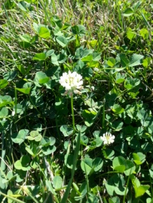  “White Clover” Image Courtesy of Kristin Bradley  White Clover.jpeg  “Untitled” by stephen jones CC BY 2.0  http://www.flickr.com/photos/stevepj2009/5853812324/  Bind Weed.jpeg  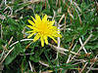  “Dandelion” by lobo235 CC BY 2.0  http://www.flickr.com/photos/lobo235/59003389/  Dandelion.jpeg  “Oxalis pes-caprae 0016” by Zachi Evenor CC BY 2.0  http://www.flickr.com/photos/zachievenor/3755827278/  Oxalis.jpeg  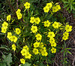  “Oxalis pes-caprae (for Wikipedia)” by Zachi Evenor  http://www.flickr.com/photos/zachievenor/8736387982/  Oxalis 2.jpeg  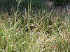  “Digitaria sanguinalis” by Matt Lavin CC BY-SA 2.0  http://www.flickr.com/photos/plant_diversity/3874836566/  Crab Grass.jpeg  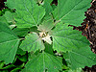  “lamb’s quarters” by Wendell Smith CC BY 2.0  http://www.flickr.com/photos/95661536@N05/9051444567/  Lambs Quarter.jpeg  “Glechoma hederacea CREEPING CHARLIE” by Frank Mayfield CC BY-SA 2.0  http://www.flickr.com/photos/gmayfield10/3328581521/  Creeping Charlie.jpeg  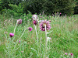  “Thistles” by oatsy40 CC BY 2.0  http://www.flickr.com/photos/oatsy40/7617659462/  Thistle.jpeg  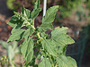  “Common Pigweed” by F.D. Richards CC BY-SA 2.0  http://www.flickr.com/photos/50697352@N00/7593676822/  Pigweed.jpeg  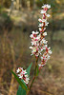  “Smartweed” by Jason Hollinger CC BY 2.0  http://www.flickr.com/photos/7147684@N03/2042935915/  Smart Weed.jpeg  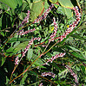  “Polygonum (or Persicaria) hydropiperoides” by Dick Culbert CC By 2.0  http://www.flickr.com/photos/92252798@N07/8671445031/  Smart Weed 2.jpeg  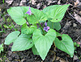  “My Back Yard – Spring Flowers –Wild Violet” by Jack Pearce CC BY-SA 2.0  http://www.flickr.com/photos/jwpearce/8740146047/  Wild Violet.jpeg  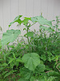  “Velvetleaf (Abutilon theophrasti)” by anneheathen CC BY 2.0  http://www.flickr.com/photos/annethelibrarian/6019541884/  Velvetleaf.jpeg  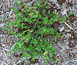  “Portulaca lutea” by David Eickoff CC BY 2.0  http://www.flickr.com/photos/dweickhoff/5188424996/  Purslane.jpeg  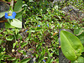  “Commelina communis” by Nacho 13 CC BY 2.0  http://www.flickr.com/photos/7858710@N02/5040973256/  Dayflower.jpeg  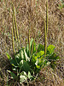  “Broadleaf Plantain” by F.D. Richards CC BY-SA 2.0  http://www.flickr.com/photos/50697352@N00/7557421042/  Plantain.jpeg  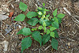  “Poison Ivy 034” by John CC BY 2.0  http://www.flickr.com/photos/cygnus921/2620415235/  Poison Ivy.jpeg  “Kat beats Poison Ivy” by KAZ Vorpal CC BY 2.0  http://www.flickr.com/photos/kazvorpal/5860678394/  Poison Ivy 2.jpeg  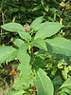  “American pokeweed, Phytolacca americana” by Tim Gibson CC BY 2.0  http://www.flickr.com/photos/53933665@N06/5039218643/  Pokeweed.jpeg  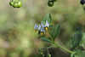  “Black Nightshade (Solanum nigrum) by Jerry Kirkhart CC BY 2.0  http://www.flickr.com/photos/jkirkhart35/1420660621/  Black Nightshade.jpeg  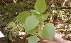  “QUICKWEED” by shastared CC BY 2.0  http://www.flickr.com/photos/shastared/5076081562/  Quickweed.jpeg  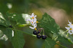  “Black Nightshade (Solanum douglasii) by Jerry Kirkhart CC BY 2.0  http://www.flickr.com/photos/jkirkhart35/2872172758/  Black Nightshade 2.jpeg  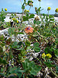  “starr-080602-5397-plant-Anagallis_arvens is-habit_with_black_medic-Along_coast_ea st_of_Bulky_Dump_Sand_Island__Midway_Ato ll”  by Forest and Kim Starr CC BY 2.0  http://www.flickr.com/photos/starr-environmental/9188115909/  Black Medic.jpeg  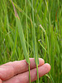  “Agropyron repens” by Matt Lavin CC BY-SA 2.0  http://www.flickr.com/photos/plant_diversity/3849552390/  Quack Grass.jpeg  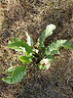  “Curly Dock” by F.D. Richards CC BY-SA 2.0  http://www.flickr.com/photos/50697352@N00/7568357808/  Curly Dock.jpeg  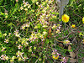  “Henbit” by klm185 CC BY 2.0  http://www.flickr.com/photos/klm185/4516264517/  Henbit.jpeg  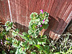  “Henbit (Lamium Amplexicaule)” by abbamouse CC BY-SA 2.0  http://www.flickr.com/photos/abbamouse/4374222229/  Henbit 2.jpeg  “Fleabane” by Jessica Crabtree CC BY 2.0  http://www.flickr.com/photos/jessicacrabtree/5286477498/  Fleabane.jpeg  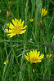  “barba di becco” by nociveglia CC BY 2.0  http://www.flickr.com/photos/40385177@N07/7320455280/  Yellow Salsify.jpeg  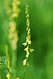  “Yellow Sweet-Clover (Melilotus officinalis)” by Joshua Mayer CC BY-SA 2.0  http://www.flickr.com/photos/wackybadger/4778484355/  Yellow Clover.jpeg  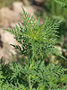  “Ambrosia artemisiifolia (Ragweed)” by F.D. Richards CC BY-SA 2.0  http://www.flickr.com/photos/50697352@N00/7556436554/  Ragweed.jpeg  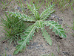  “Carduss nutans” by Matt Levin CC BY-SA 2.0  http://www.flickr.com/photos/plant_diversity/5841906493/  Musk Thistle.jpeg  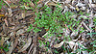  “Chickweed-Stellaria media” by John Tan CC BY 2.0  http://www.flickr.com/photos/31031835@N08/9642726485/  Chickweed.jpeg  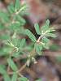  “Prostrate Spurge” by F.D. Richards CC BY-SA 2.0  http://www.flickr.com/photos/50697352@N00/7605987250/  Prostrate Spurge.jpeg  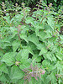  “Stinging Nettles (Urtica dioica)” by Leonora Enking CC BY-SA 2.0  http://www.flickr.com/photos/33037982@N04/7264042430/  Stinging Nettles.jpeg
Quiz | Unit Three Quiz
Content | 1. Kentucky bluegrass is a winter hardy perennial grass that tolerates close grazing.  a. True (correct 2 pts)  b. False  2. Tall fescue is a high yielding grass for hay and pasture.  a. True (correct 2 pts)  b. False  3. A major strength of red clover is which of the following?  a. b. Drought tolerant  b. Easy to establish (correct 2 pts)  c. Grows well in all soil  d. Not susceptible to root disease  4. A major strength of alfalfa is which of the following?  a. Tolerant to wet and poorly drained soil  b. Suited for frost seeding  c. Drought tolerant (correct 2 pts)  d. Resistant to the potato leaf hopper insect  5. When choosing forages it is important to consider which of the following?  a. Yield potential  b. Forage quality  c. Winter-hardiness  d. All of the above (correct 2pts)
Content  Attributions | James Donaldson, course developer
Discussion Board | “Crabgrass Anyone?”
Content | Read the article “Crabgrass Friend or Foe?” located at  http://www.caes.uga.edu/commodities/fieldcrops/forages/Ga_Cat_Arc/2002/Aug02.pdf .  Usually crabgrass is not a commonly used forage grass but rather thought of as a pest grass. After reading the articles what do you think about Dr. Andrae’s assessment of crabgrass? Post your response (at least one paragraph) to the discussion board and respond to at least one other classmates post. Many of you might have different opinions (which are good!) so remember to keep the discussion respectful.
Content Attribution | Dr. John Andrae, Extension Forage Specialist Department of Crop and Soil Science the University of Georgia.  James Donaldson, content developer
Links/Uploads | “Crabgrass Friend or Foe?”  http://www.caes.uga.edu/commodities/fieldcrops/forages/Ga_Cat_Arc/2002/Aug02.pdf .
Dropbox Assignment | “Identify Your Weeds”
Image
Image Attribution | Replaced  http://www.flickr.com/photos/21561428@N03/5780321783  by las – initially, CC BY-NC-ND 2.0
Content | In this assignment you will do a hands-on activity to help identify weeds in your area.  Complete the following steps to Identify Your Weed:  - View the Weed Identification Power Point  - Find two examples of weeds in your area that are also depicted in the guide.  - Photograph your weeds with a digital camera.  - Compile a short report using Microsoft Word and insert your photos in the document.  - In your report include the following information: name of weed, description of weed, where it was growing when you found it and how to prevent it from growing where you don’t want it to grow.  - Turn the document into the Dropbox.
Content  Attribution | James Donaldson, course developer
Links/Uploads | Unit Three Assignment.pdf
Announcements

Unit 4
Title | Formulating Seed Mixes for Yield and Nutrition
Landing Page  Image | 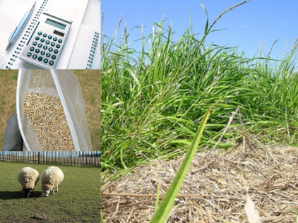  Unit Four Landing .png
Image/Image  Attribution | 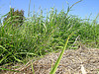  “Lolium perenne habit” by Harry Rose CC BY 2.0  http://www.flickr.com/photos/macleaygrassman/6919845199/  Perennial Rye Grass.jpeg  “Calculator, Pen and Calendar” by photosteve101 CC BY 2.0  http://www.flickr.com/photos/42931449@N07/6812484625/  Calculator Pen and Calendar.jpeg  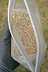  “bag of grass seed” by http://www.homespothq.com CC BY 2.0  http://www.flickr.com/photos/86639298@N02/10086950306/  Grass Seeds.jpeg  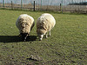  “Grazing” by Kieran Lamb CC BY-SA 2.0  http://www.flickr.com/photos/western4uk/108252720/  TwoSheep.jpeg
Content  Overview | In this unit you will learn how to formulate seed mixes for good pasture management.
Objectives | In this unit you should:  - Formulate seed mixes for pasture.
Outcomes | Understand the formulas and strategies for establishing proper seed mixes for pastures.
To-Do-List | - Read the two readings for this week “Forage Crop Seed Mixture Formulation” and “Steps to Establish and Maintain Legume - Grass Pastures”  - Attend Live Seminar  - Complete the Discussion Board “Forages Strengths and Weaknesses” (15pts)  - Complete Dropbox Assignment One: “Calculate Your Forage Mixture” (25 pts)  - Complete the Dropbox Assignment Two: “SANET Listserv”  (25 pts)  - Take the Quiz over the readings (10 pts)
Links/Uploads | SLF 125_Unit Four Instructions.doc
Unit 4 Activities
Reading One | “Forage Crop Seed Mixture Formulation”
Image/Image Attribution | 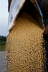  “Emptying a Seed Bag” by United Soybean Board CC BY 2.0  http://www.flickr.com/photos/unitedsoybean/9629680277/  Pouring Seed.jpeg
Content | Navigate to the “Forage Crop Seed Mixture Formulation” article located at http://library.ndsu.edu/repository/handle/10365/17300 (Click on PDF to view article) This article discusses selecting seed mixtures and characteristics as well as gives a worksheet for figuring your seed mix.  - How complex should your seed mixtures be?  - What factors should be considered when selecting a forage crop?  - What data do you need to figure the number of pure live seeds required per square foot of pasture?
Content Attribution | North Dakota State University Depository. Cooperative Extension Service. Author: Duaine Dodds, Grassland Management Specialist  James Donaldson, course developer
Links/Uploads | “Forage Crop Seed Mixture Formulation” http://library.ndsu.edu/repository/handle/10365/17300 (Click on PDF to view article)
Reading Two | “Steps to Establish and Maintain Legume-Grass Pastures”
Image/Image Attribution | 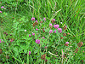  “Trifolium pratense habit3” by Harry Rose CC BY 2.0  http://www.flickr.com/photos/macleaygrassman/10733500486/  CloverLegume.jpeg
Content | Navigate to the article “Steps to Establish and Maintain Legume-Grass Pastures” located at http://www.extension.iastate.edu/publications/pm1008.pdf This article gives forage seed mix recommendations, seeding steps and advice for future management.  - What are some forage seed mixture recommendations for common Midwest pasture forages?  - What are some types of seeding recommendations?  - What are some ways to manage your forages after establishment?
Content Attribution | Author: Stephen K. Barnhart, Iowa State University Extension and Outreach agronomist.  James Donaldson, course developer
Links/Uploads | “Steps to Establish and Maintain Legume-Grass Pastures” http://www.extension.iastate.edu/publications/pm1008.pdf
Live Seminar (Big Blue Button) | “Final Project Continued”
Content | Purpose: Discuss final aspects of project reviewing components from Units 1-4 that they will need to be prepared to include. Also to review the final assignment sheet. (attached as a Word doc)
Links/Uploads | Final Project Assignment Sheet.doc
Content Attribution | James Donaldson, course developer
Quiz | Unit Four Quiz
Content | - Seed mixtures should be:  - Complex  - Simple (correct 2 pts)  - Compound  - None of the above  - Usually seed mixtures should contain:  - As many varieties of grasses and legumes that can be purchased  - At least one grass and one legume (correct 2 pts)  - No legumes  - Only seed on sale  - Factors that should be considered when selecting forage varieties for seed mixes are growth season, potential yield, compatibility and soil adaptation. (True/False)  a. True (correct, 2pts)  b. False  - To prepare your pasture for seeding when a seed bed will follow a row crop which of the following can be used?  - Disc  - Harrow  - Secondary Tillage  - All of the above (correct, 2pts)  - To prepare your pasture for seeding when renovating a pasture which of the following might you use?  - Labeled herbicides  - Shallow plowing  - Disking with a brush disc  - All of the above (correct 2 pts)
Content  Attributions | James Donaldson, course developer
Discussion Board | “Forages Strengths and Weaknesses”
Content | When you are choosing forage species there is no magic combination. All, legumes and grasses, and forage species have strengths and weaknesses.  In this discussion post choose a specific livestock that matches one of the forage seed mixture from the recommendations provided in the reading “Steps to Establish and Maintain Legume-Grass Pastures”. Please explain your reasoning for your choice including the strengths and weaknesses associated with it. You may have to do some additional research by talking to farmers or people you know who have chosen forage mixes or conduct an internet search on the topic.  Include at least one paragraph including a strength and a weakness of the forage you chose to the discussion board.
Content Attributions | James Donaldson, course developer
Dropbox Assignment One | “Calculate Your Forage Mixture”
Images/Image Attributions | “bag of grass seed” by http://www.homespothq.com CC BY 2.0  http://www.flickr.com/photos/86639298@N02/10086950306/  Grass Seeds.jpeg  “Calculator, Pen and Calendar” by photosteve101 CC BY 2.0  http://www.flickr.com/photos/42931449@N07/6812484625/  Calculator Pen and Calendar.jpeg  “Grazing” by Kieran Lamb CC BY-SA 2.0  http://www.flickr.com/photos/western4uk/108252720/  TwoSheep.jpeg
Content | Using the “Forage Crop Seed Mixture Formulation” reading choose your own grazing mixture from the pasture forage species studied thus far and calculate your forage crop seed mixture. (For reference study the example calculations from the reading to help you) Show your work in a Microsoft Word document and upload to the Dropbox. View the example below: (This table/calculation is what you need to turn in) To make a table in Microsoft Word choose the “Insert” tab and then choose “Table.” Insert 6 columns and 7 rows like the example.  Steps:  - List species to be planted in column 1  - List percent of composition that is desired in column 2  - Get column 3 data from table 4 in the reading  - Complete column 4 by multiplying column 2 and 3 for each species you chose  - For column 5 list # of seeds/square foot/pound of seed planted for each species. Get data from table 3 in the reading.  - Complete column 6 by dividing column 4 by 5. This will equal you PLS seeding rate/acre for each species you listed.  - Total column 6. This is your total PLS seeding rate/acre.  Species (1) % Composition Desired (2) Total Seeds (3) Number of Seeds per Sq Ft. TOTAL (4) Number of Seeds per Sq Ft PER POUND (5) Pounds PLS per Acre (6)  TABLE 4 (data in reading) Column 2 X 3 TABLE 3 (data in reading) Columns 4 + 5  TOTALS 100
Links/Uploads | Unit Four Assignment One.pdf
Content  Attribution | Formula from “Forage Crop Seed Mixture Formulation” reading. North Dakota State University Depository. Cooperative Extension Service. Author: Duaine Dodds, Grassland Management Specialist  James Donaldson, course developer
Dropbox Assignment Two | “SANET listserv”
Images/Image Attributions | 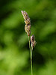  “Orchard Grass” by John B. CC BY 2.0  http://www.flickr.com/photos/dendroica/8963185913/  Orchard Grass.jpeg  “Soybean Field” by United Soybean Board CC BY 2.0  http://www.flickr.com/photos/unitedsoybean/9624051488/  Soybean Field.jpeg  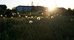  “Dandelions” by Katie Brady CC BY 2.0  http://www.flickr.com/photos/cliche/4648993440/  SunDandelions.jpeg
Content | This assignment has two parts. For part one you need to join the SANET listserv. This listserv is sponsored by Sustainable Agriculture Research and Education (SARE) under the USDA. This online listserv is a valuable resource and discussion forum where you can receive information about sustainable agriculture, post questions you might have to the forum groups and also receive answers. This type of forum operates through your email address. To sign up follow the link: http://www.sare.org/Learning-Center/SANET-Listserv and click on the “Join or Leave” option. Follow the prompts to join the listerv. First enter the email address in which you would like to use, then fill in your name and keep everything else listed as it already selected.  If you wish to leave the listserv after this class you would follow the same steps, but choose the “leave” option. I highly recommend keeping your subscription to help you keep up-to-date on the current and future issues following sustainable agriculture.  For part two of this assignment research the SANET listerv’s archives located at the link: http://sanet.sare.org/archives/sanet-mg.html . Click on a month to investigate and choose one of the topics that interest you. In a Microsoft Word document include the link or URL to the post you chose, a short summary of the post and what you learned by reading the post. You can also discuss any questions you have after reading the information or general insights or opinions you have about the topics. This assignment should be two paragraphs in length.
Content  Attribution | James Donaldson, course developer
Links/Uploads | Unit Four Assignment Two.pdf

Unit 5
Title | “Carrying Capacity and Stocking Rate”
Landing Page  Image | 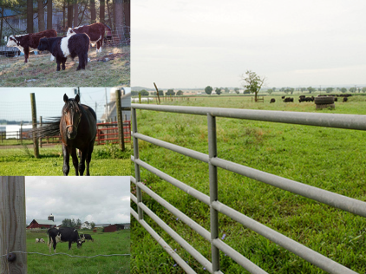  Unit Five Landing .png
Image/Image  Attribution | 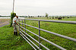  “20130712-AMS-LSC-0361.jpg” by U.S. Department of Agriculture CC BY 2.0  http://www.flickr.com/photos/usdagov/9303118533/  ClosingGate.jpeg  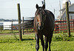  “Horse walking over to see what I wanted” by Todd Ryburn CC BY 2.0  http://www.flickr.com/photos/tryburn/3673596280/  HorseFence.jpeg  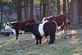  Cows in the Pasture” by Tim Sackton CC BY-SA 2.0  http://www.flickr.com/photos/sackton/8227828089/  ThreeCows.jpeg  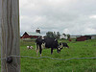  “cows in pasture (also a jigsaw puzzle) by uhuru1701 CC BY-SA 2.0  http://www.flickr.com/photos/uhuru1701/2249220340/  FenceCows.jpeg
Content  Overview | In this unit you will learn about rotational grazing and understand how to establish a correct stocking rate formula for your pasture management plan.
Objectives | In this unit you should:  - Determine the appropriate stocking rate, given the size of the pasture and type of livestock.  - Evaluate the duration that a given pasture should be grazed based on environmental conditions and stocking rate.
Outcomes | - Understand how to access size of pasture and amount of livestock for correct stocking rate.  - Know the duration that a pasture can be grazed based on various environmental conditions.  - Understand grazing rotation practice and methods.
To-Do-List | - Read the three readings for this week “Determining You’re Stocking Rate”, “Determining Forage Production and Stocking Rates: A Clipping Procedure for Range Lands”and “Pastures Grazing Management”  - Watch videos over Managed Grazing  - Complete the Discussion Board “Video Discussion” (15 pts)  - Complete the Dropbox Assignment “Determining Your Stocking Rate”(25 pts)  - Take the Quiz over the readings (10 pts)
Links/Uploads | SLF 125_Unit Five Instructions.doc
Unit 5 Activities
Reading One | “Determining Your Stocking Rate”
Image/Image Attribution | 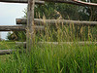  “Renegade Grass” by ..stiina..” CC BY 2.0  http://www.flickr.com/photos/34419934@N03/3204993444/  GrassWood Fence.jpeg
Content | To read the article navigate to the Utah State University Extension site located at https://extension.usu.edu/htm/publications/publication=6247 . Then click on the “Determining Your Stocking Rate” pdf. This article gives you a detailed explanation and examples of how to calculate your own stocking rate.  - Why is knowing forage yield important for calculating stocking rate?  - What is an Animal Unit Month (AUM)?  - What is an Animal Unit Equivalent (AUE)?  - What are the differences between average animal weight method stocking rate problem and the classic stocking rate problem?
Content Attribution | Utah State University Cooperative Extension  Mindy Pratt and G. Allen Rasmussen, May 2001  James Donaldson, course developer
Links/Uploads | “Determining Your Stocking Rate” https://extension.usu.edu/htm/publications/publication=6247
Reading Two | “Determining Forage Production and Stocking Rates: A Clipping Procedure for Range Lands”
Image/Image Attribution | 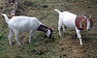  “Cassie and Mercedes” by floodllama CC BY 2.0  http://www.flickr.com/photos/38446022@N00/2699141206/  Goatsinpasture.jpeg
Content | To read “Determining Forage Production and Stocking Rates: A Clipping Procedure for Range Lands” navigate to the following linked PDF: http://extension.usu.edu/BEHAVE/files/uploads/Low-Moisture%20Block/Estimating%20Range%20Production.pdf .  This article gives you step by step directions to measure forage production in order to better determine your stocking rate.  - What methods need to be used to determine stocking rate?  - When should pasture forages be clipped?  - What materials are needed to calculate forage yield?  - What are the steps for measuring forage production?
Links/Uploads | http://extension.usu.edu/BEHAVE/files/uploads/Low-Moisture%20Block/Estimating%20Range%20Production.pdf .
Content Attribution | Larry Brence, Fallon-Carter County Extension Agent, and Roger Sheley,  Extension noxious weeds specialist, MSU-Bozeman.  Copyright © 2003 MSU Extension Service  James Donaldson, course developer
Reading Three | “Pastures Grazing Management”
Image/Image Attribution | “RGB” by jeff_w_brooktree CC BY-SA 2.0  http://www.flickr.com/photos/trj/306749214/  PastureFall.jpeg
Content | To read “Pastures: Grazing Management” navigate to the Penn State Extension located at http://extension.psu.edu/ . Scroll down to the “Plants and Pests” heading and click on “Crops and Soils.” Then choose the blue “Agronomy Guide” button from the bar on the left hand side. Again go to the left hand side of the page and click on “Crop and Soil Management.” From the “Crop and Soil Management table of contents choose “Section 8 Forages” and then scroll down to the “Pastures” heading (close to the bottom of the page) and choose “Grazing Management.” Read the “Pastures: Grazing Management” article.  - What is the importance of grazing pressure and stocking rate?  - What is continuous grazing?  - What is rotational grazing  - What is creep grazing?  - What is mixed grazing?
Content Attribution | © 2013 College of Agricultural Sciences Penn State Extension  James Donaldson, course developer
Links/Uploads | LINK to website: http://extension.psu.edu/  LINK to ARTICLE : http://extension.psu.edu/agronomy-guide/cm/sec8/sec810l
Video Assignment | “Managed Grazing”
Content | View the following videos on managing grazing. These videos introduce managed grazing and discuss managing livestock, forage plants and resources in managed grazing plans.  - “Managed Grazing- Part 1-Introduction to Managed Grazing” http://www.youtube.com/watch?v=slaWPxCKB9Y  - “Managed Grazing – Part 2- Animal Management” http://www.youtube.com/watch?v=dqOiSxviD0Y  - “Managed Grazing –Part 4-Managing Pasture Plants” http://www.youtube.com/watch?v=VUHIEecpkBk  - “Managed Grazing-Part5-Year Around Resource Management” http://www.youtube.com/watch?v=jrqvOGXHzeQ
Content Attributions | “Managed Grazing- Part 1-Introduction to Managed Grazing” - Iowa State University Extension 1995 - VID 0018. Standard YouTube License  “Managed Grazing – Part 2- Animal Management” Iowa State University Extension 1995 - VID 0018. Standard YouTube License.  “Managed Grazing –Part 4-Managing Pasture Plants” Iowa State University Extension 1995 - VID 0018. Standard YouTube License.  “Managed Grazing-Part5-Year Around Resource Management” Iowa State University Extension 1995 - VID 0018. Standard YouTube License.
Links/Uploads | - “Managed Grazing- Part 1-Introduction to Managed Grazing” http://www.youtube.com/watch?v=slaWPxCKB9Y  - “Managed Grazing – Part 2- Animal Management” http://www.youtube.com/watch?v=dqOiSxviD0Y  - “Managed Grazing –Part 4-Managing Pasture Plants” http://www.youtube.com/watch?v=VUHIEecpkBk  - “Managed Grazing-Part5-Year Around Resource Management” http://www.youtube.com/watch?v=jrqvOGXHzeQ
Quiz | Unit Five Quiz
Content | - When designing a pasture management plan selection of a grazing management practice is  - Not very important  - Very important (correct 2pts)  - Unknown  - Not an accepted practice  - Common grazing management practices are:  - Continuous grazing  - Mixed grazing  - Creep grazing  - Rotational grazing  - All of the above (correct 2 pts)  - To maintain a productive pasture in a continuous grazed system it is important to avoid:  - Fertilizing  - Resting  - Over grazing (correct 2 pts)  - None of the above  - Mixed grazing is explained as:  - Grazing livestock on mixed grasses  - Grazing mixed colored livestock  - Grazing pastures with just cattle  - Grazing of pastures by two or more species of animals (correct 2 pts)  - More intensive rotational grazing systems have seven or more paddocks in which are grazed. (True/False) (True 2 pts)
Content  Attributions | James Donaldson, course developer
Discussion Board | “Video Discussion”
Content | After viewing the assigned videos, choose an aspect of pasture management that was discussed.  For example:  What did you find most interesting?  Were there any new concepts to you?  What would you like to learn more about?,  What did you disagree with?  Did anything surprise you?  Write a one to two paragraph statement about that topic. Respond to at least one other classmate’s post. Remember to provide a more detailed response than just a simple “I like your post” or “I agree with you.” Discuss what you learned in the videos.
Content Attributions | James Donaldson, course developer
Dropbox Assignment | “Determining You’re Stocking Rate”
Images/Image Attributions | “Cows in the Pasture” by Tim Sackton CC BY-SA 2.0  http://www.flickr.com/photos/sackton/8227828089/  ThreeCows.jpeg  “cows in pasture (also a jigsaw puzzle) by uhuru1701 CC BY-SA 2.0  http://www.flickr.com/photos/uhuru1701/2249220340/  FenceCows.jpeg  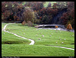  “Bolton Abbey Sheep Pasture Path to Wharfe River Bridge” by Pamela J. Eisenberg CC BY-SA 2.0  http://www.flickr.com/photos/27398485@N08/2554950207/  SheepPasture.jpeg
Content | For this assignment interview a livestock owner asking them the following questions:  1. How do they determine their stocking rate? (Remember to ask for exact numbers or resources).  2. What are their grazing rotation practices and methods?  Compile a report of your interview in a Microsoft Word document and upload to the Course Dropbox. This assignment should be 2 paragraphs in length.
Links/Uploads | Unit Five Assignment .pdf
Content  Attribution | James Donaldson, course developer

Unit 6
Title | “Calculating Yield”
Landing Page  Image | 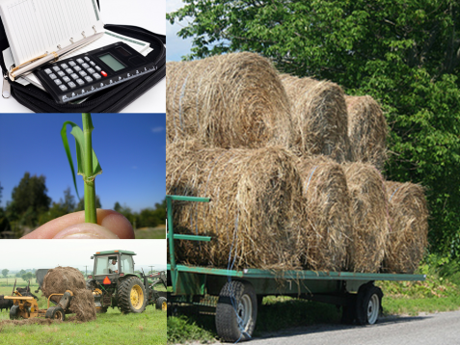  Unit Six Landing .png
Image/Image  Attribution | 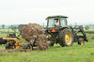  “20130712-AMS-LSC-0375.jpg” by U.S. Department of Agriculture CC BY 2.0  http://www.flickr.com/photos/usdagov/9303122151/  HayTractor.jpeg  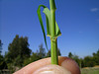  “Lolium perenne auricles3” by Harry Rose CC BY 2.0  http://www.flickr.com/photos/macleaygrassman/7370360116/  Rye Grass Stem.jpeg  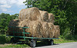  “Hay Bales” by Robert Taylor CC BY 2.0  http://www.flickr.com/photos/bobolink/3782535152/  Haybales.jpeg  “Calculator, pen and agenda in black organizer case” by Horia Varlan CC BY 2.0  http://www.flickr.com/photos/horiavarlan/4273218381/  Calculatororganizer.jpeg
Content  Overview | In this unit you will learn the steps and processes to follow to determine dry matter yield. You will also investigate how farmers in your area calculate their yields.
Objectives | In this unit you should:  - Estimate dry matter yield of the forage species and mixed pasture types studied.
Outcomes | - Be able to understand the dry matter yield for different forage species.
To-Do-List | - Read the two readings for this week “Calculating Hay Yields” and “Lesson 1 Determining Forage Yield Activity Sheet”  - Complete the Discussion Board “Share Your Thoughts” (15pts)  - Complete the Dropbox Assignment “Information Hunt”( (25 pts)  - Take the Quiz over the readings (10 pts)
Links/Uploads | SLF 125_Unit Six Instructions.doc
Unit 6 Activities
Reading One | “Calculating Hay Yields”
Image/Image Attribution | 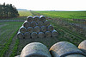  “Hay Bales, Cherhill” by Nick CC BY 2.0  http://www.flickr.com/photos/34517490@N00/6366229763/  Stacked Hay.jpeg
Content | Read the “Calculating Hay Yields” reading located at the Purdue Extension http://www.agry.purdue.edu/ext/forages/rotational/articles/PDFs-articles/calculating-hay-yields.pdf .  This reading explains why you want to calculate hay yield and gives you an example and formula to use.  - Why would you want to calculate hay yield?  - What numbers/data do you need to know before you can calculate hay yield?  - What values do you need to calculate hay yield?  - How do you properly calculate hay yield?
Content Attribution | Danny Greene, Stephen Hawkins, and Keith Johnson Department of Agronomy, David Petritz Department of Agricultural Economics, David Trotter Clark County Agricultural Agent Purdue University  James Donaldson, course developer
Links/Uploads | http://www.agry.purdue.edu/ext/forages/rotational/articles/PDFs-articles/calculating-hay-yields.pdf .
Reading Two | “Lesson 1 Determining Forage Yield and Activity Sheet”
Image/Image Attribution | 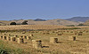  “More of Those Hay Bales” by Linda Tanner CC BY 2.0  http://www.flickr.com/photos/goingslo/7302778178/  LostofHay.jpeg
Content | Read the “Lesson 1 Determining Forage Yield Activity Sheet” located at the University of Montana Extension  http://www.animalrangeextension.montana.edu/lol/module-4a/4-yield.htm.  This reading gives you a detailed look at the process/steps you need to follow when determining forage yield.  - What is forage yield?  - What type of equipment do you need to calculate forage yield?  - What steps do you need to follow to properly calculate forage yield?
Links/Uploads | http://www.animalrangeextension.montana.edu/lol/module-4a/4-yield.htm.
Content Attribution | University of Montana Animal Range Extension  (Acknowledgement: Taken from "Living on the Land 2001")  James Donaldson, course developer
Quiz | Unit Six Quiz
Content | 1. By determining hay yield you can make changes that will help increase potential profits. (true/false)  a. True (correct, 2 pts)  b. False  2. To calculate hay yields in dry tons per acre you need to know:  a. Acreage of the field  b. Number of bales per harvest  c. Average weight of bales in each harvest  d. All of the above (correct 2 pts)  3. Forage yield is the amount of forage dry matter available in a pasture on a per acre basis. (true/false)  a. True (correct, 2 pts)  b. False  4. Equipment needed to determine forage yield include:  a. Tractor  b. Hoop (correct, 2 pts)  c. Combine  d. Coffee cans  5. An easy way to construct a hoop is to:  a. Bolt together the ends of two 8 feet long ¼ inch cables (correct 2 pts)  b. Glue together the ends of two pieces of wire  c. Buy a children’s Hula Hoop  d. Hoops aren’t needed in the process
Content  Attributions | James Donaldson, course developer
Discussion Board | “Share Your Thoughts”
Content | For this discussion board you will share your thoughts on what you have learned in this unit. You may pose a question you have about calculating yield, share an insight you have about the process, tell a story about your experience (or farmer you know) with calculating yield and/or thoughts or questions you have about the formulas and materials used. Please respond to at least one other classmates post. Be sure to go beyond just stating “I agree” or “good post.”
Content Attributions | James Donaldson, course developer
Dropbox Assignment | “Information Hunt”
Images/Image Attributions | “20130712-AMS-LSC-0375.jpg” by U.S. Department of Agriculture CC BY 2.0  http://www.flickr.com/photos/usdagov/9303122151/  HayTractor.jpeg
Content | For this assignment you will gather more information on calculating dry matter yield of your local forage species (remember we identified these in Unit 3). To further investigate how farmers in your area estimate/calculate their forage species dry matter yield you may call local extension center, interview a farmer you know or search the web. Post your findings to the discussion board. Your report should be at least 1-2 paragraphs and contain the following information:  1. Type of forage species you investigated  2. Method you used to find information (interview, phone call, internet search)  3. Who you talked with or what site gave you the information (include the website address if you did a web search)  4. Discuss what you found and how it can help you calculate dry matter yield in the future.
Links/Uploads | Unit Six Assignment .pdf
Content  Attribution | James Donaldson, course developer

Unit 7
Title | “Equipment, Planting and Maintenance”
Landing Page  Image | 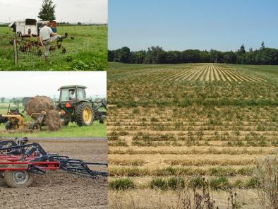  Unit Seven Landing .png
Image/Image  Attribution | “Harvested Grass Seed field” by born1945 CC BY 2.0  http://www.flickr.com/photos/12567713@N00/227607861/  Harvested Grass Field.jpeg  “20130712-AMS-LSC-0375.jpg” by U.S. Department of Agriculture CC BY 2.0  http://www.flickr.com/photos/usdagov/9303122151/  HayTractor.jpeg  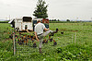  “20130712-AMS-LSC-0670.jpg” by U.S. Department of Agriculture CC BY 2.0  http://www.flickr.com/photos/usdagov/9299760159/  ChickensFence.jpeg  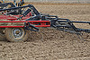  “Tilling the Fields” by United Soybean Board CC BY 2.0  http://www.flickr.com/photos/unitedsoybean/9626018912/  Field Cultivator.jpeg
Content  Overview | In this unit you will learn about the tools and equipment you need for pasture maintenance and management. You will also learn about methods, timing and appropriate seeding rates for establishing pasture forage species.
Objectives | In this unit you should:  - Identify tools and equipment used for pasture management.  - Describe all appropriate methods of planting and establishing the forage species studied.  - Identify appropriate timing for seeding the forage species studied.  - Identify appropriate seed rates for the forage species studied.
Outcomes | - Know the various tools and equipment for pasture management.  - Be able to describe and identify methods, timing and appropriate seed rates for forage species studied.
To-Do-List | 1. Read “Hay and Pasture” pages 1-7 (stop at “Hay Harvest Management section) by Jim Morrison from the Rockford Illinois Extension Center  2. View the Power Point: “Tools and Equipment for Pasture Management”  3. Watch the videos: “Brush Cutter” and “How To: Operate and Drive a Tractor: Part 1”  4. Complete the Dropbox Assignment: “Final Project Rough Draft” (25 pts)  5. Complete the Discussion Board: “Final Project Discussion” (25pts)  6. No Quiz this week! The Discussion Post is worth an additional 10 points.  Plow – used to prepare soil for planting. Turns over the top layer of soil, burying weeds and bringing nutrients to the surface. Preventative maintenance includes: checking wing blades, hydraulic hoses and connections and wing markers.  Disc– used to prepare soil for planting by turning over soil, loosening soil and removing weeds. Preventative maintenance includes greasing zerts or replacing barring's. Some farmers have moved away from using discs because they cause soil compaction and inhibits the roots of crops penetrating deeper into the soil. This is not usually a problem for forages as they germinate in the top quarter inches of the soil.  Seed Drill - A seed drill positions the seed in the soil and then covers them. For preventative maintenance grease every 100 hours , wash when done for season and clean hopper and seed boxes out.  Broadcast Seeder - spreads or “slings” the seed across the ground then pushes it into the soil. After you use it make sure fittings are greased and box is cleaned out.
Links/Uploads | SLF 125_Unit Seven Instructions.doc
Unit 7 Activities
Reading | “Hay and Pasture”
Image/Image Attribution | 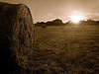  “Hay Bales” by Timo Newton-Syms CC BY-SA 2.0  http://www.flickr.com/photos/timo_w2s/4718272365/  BalesSun.jpeg
Content | Read the article “Hay and Pasture” pages 1-7 (stop at “Hay Harvest Management section) by Jim Morrison from the Rockford Illinois Extension Center http://extension.cropsci.illinois.edu/handbook/pdfs/chapter06.pdf  This reading gives a detailed and in-depth look at establishing pasture grasses and legumes, forage and seeding rate recommendations.  - How can you evaluate older hay pastures?  - What are the steps to follow to renovate a pasture?  - What are best seeding dates?  - What are some forage seeding-rate recommendations for Illinois hay and pasture?  - What are some differences between band seeding and broadcast seeding?  - What is proper seeding depth?
Content Attribution | Jim Morrison from the Rockford Illinois Extension Center  James Donaldson, course developer
Links/Uploads | http://extension.cropsci.illinois.edu/handbook/pdfs/chapter06.pdf
Power Point | “Tools and Equipment for Pasture Management”
Content | View the Power Point content “Tools and Equipment for Pasture Management”
Links/Uploads | Unit Seven Power Point.pptx
Content Attribution | James Donaldson, course developer
Images/Image Attributions | “Tilling the Fields” by United Soybean Board CC BY 2.0  http://www.flickr.com/photos/unitedsoybean/9626018912/  Field Cultivator.jpeg  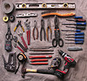Used in Reading & Audio (Tools & Equipment Used in Pasture Management)  “Tools” Photo By velacreations, CC By 2.0  http://www.flickr.com/photos/35090117@N05/5249327029/in/photolist-  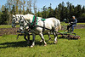  “grey Team 03.jpeg” by Nikki CC BY-SA 2.0  http://www.flickr.com/photos/nikkis_pikkis/410908523/  Horses Discing.jpeg  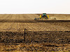  “0420 spring work” by David Morris CC BY 2.0  http://www.flickr.com/photos/revdave/466536576/  TractorDiscing.jpeg  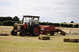  “Hay Baling - Small Square Bales - Co. Meath Ireland - July 1st 2013” by Peter Mooney CC BY-SA 2.0  http://www.flickr.com/photos/peterm7/9183333509/  SquareBales.jpeg  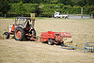  “Hay Baling - Small Square Bales - Co. Meath Ireland - July 1st 2013” by Peter Mooney CC BY-SA 2.0  http://www.flickr.com/photos/peterm7/9183339599/  SquareBales2.jpeg  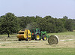  “Baling the hay” by peggydavis66 CC BY-SA  http://www.flickr.com/photos/11441121@N04/2626198178/  Roundbales.jpeg  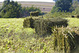  “Untitled” by Claus Rebler CC BY-SA 2.0  http://www.flickr.com/photos/zunami/2819346580/  Square Bale Row.jpeg  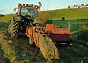  “Baling at Sunset” by possumgirl2 CC BY-SA 2.0  http://www.flickr.com/photos/possumgirlpics/5560244479/  Square Bale Out.jpeg  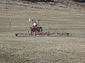  “Spring Harrowing” by USFWS Mountain Prairie CC BY 2.0  http://www.flickr.com/photos/usfwsmtnprairie/8139377444/  Harrowing.jpeg  “Dadford Harrow” by Keith Williams CC BY 2.0  http://www.flickr.com/photos/92306213@N00/288435355/  Harrow.jpeg  “Speed the harrow” by lostinfog CC BY-SA 2.0  http://www.flickr.com/photos/lostinfog/3155581094/  Harrow Tracks.jpeg  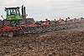  “Tilling the Fields” by United Soybean Board CC BY 2.0  http://www.flickr.com/photos/unitedsoybean/9626005388/  Tilling,jpeg  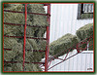  “Foin 2008 – Hay 2008” by Lucie Provencher CC BY-SA 2.0  http://www.flickr.com/photos/gattou/2638213099/  Hayloader.jpeg  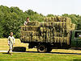  “loading hay” by liz west CC BY 2.0  http://www.flickr.com/photos/calliope/22134723/  Hayloaders.jpeg  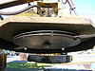  “Railroad Brush Cutter” by brewbooks CC BY-SA 2.0  http://www.flickr.com/photos/brewbooks/304760097/  Railroadbrushcutter.jpeg  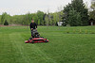  “New mower” by Tim Wilson CC BY 2.0  http://www.flickr.com/photos/timwilson/6982908586/  RidingMower.jpeg  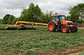  “Vermeer TM1400 Trailed Mower” by Edmund Garman CC BY 2.0  http://www.flickr.com/photos/3cl/5907890584/  Tractor Mower.jpeg  “Polaris RZR ATV” by Pete Markham CC BY-SA 2.0  http://www.flickr.com/photos/pmarkham/4338754972/  ATV1.jpeg  “ATV Riding Trails On Kauai, Hawaii” by TRAILSOURCE.COM CC BY 2.0  http://www.flickr.com/photos/trailsource/181080368/  ATV2.jpeg  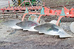  “Nicely polished plow” by Dwight Sipler CC BY 2.0  http://www.flickr.com/photos/photofarmer/3521143839/  Plow.jpeg  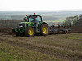  “Ploughing near Saxby All Saints” by David Wright CC BY 2.0  http://www.flickr.com/photos/dhwright/6312683001/  Tractor Plow.jpeg  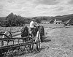  “20111110-OC0-AMW-0247” by U.S. Department of Agriculture CC BY 2.0  http://www.flickr.com/photos/usdagov/6595065949/  Side Rake.jpeg  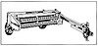  “Dibble sticks, donkeys and diesels_p224” by IRRI Photos CC BY 2.0  http://www.flickr.com/photos/ricephotos/9002783266/  Mower Conditioner.jpeg  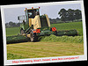  “Silage Harvesting - Co. Meath, Ireland. May 2011” by Peter Mooney CC BY-SA 2.0  http://www.flickr.com/photos/peterm7/5760981020/  Mower Conditioner 2.jpeg  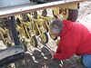  “USDA NRCS Plant Materials Center’s Drill” by USDA NRSC South Dakota CC BY-SA 2.0  http://www.flickr.com/photos/nrcs_south_dakota/7303657976/  Plant Drill Up Close.jpeg  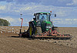  “Seed Drilling on Saxby Wold” by David Wright CC BY 2.0  http://www.flickr.com/photos/dhwright/6220267993/  Seed Drilling.jpeg  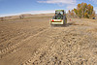  “Truax Broadcast Seeder” by USFWS Mountain Prairie CC BY 2.0  http://www.flickr.com/photos/usfwsmtnprairie/5223639947/  Broadcast Seeder.jpeg  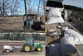  “Native Species Planting in Restoration Area” by USFWSmidwest CC BY 2.0  http://www.flickr.com/photos/usfwsmidwest/8318369956/  Broadcast Seeder 2.jpeg  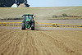  “IMG_1315 (2400x1600)” by Chafer Machinery CC BY 2.0  http://www.flickr.com/photos/chafermachinery/9552998663/  Tractor Sprayer.jpeg  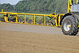  “IMG_1341 (2400x1600)” by Chafer Machinery CC BY 2.0  http://www.flickr.com/photos/chafermachinery/9555779720/  Sprayer arm close up.jpeg  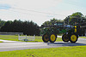  “Omar Delaware” by Lee Cannon CC BY-SA 2.0  http://www.flickr.com/photos/leecannon/6099165238/  Tractor Weed Sprayer.jpeg  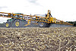  “IMG_1418 (2400x1600)” by Chafer Machinery CC BY 2.0  http://www.flickr.com/photos/chafermachinery/9555762324/  Post Emergence Spraying.jpeg
Video | “Brush Cutter”
Content | Watch the video “Brush Cutter” located at http://www.youtube.com/watch?v=ZOAiNEHrWAQ  This video gives you an in-depth look into brush cutter operation and use.
Content Attribution | “Brush Cutter” by PublicResourceOrg  http://www.youtube.com/watch?v=ZOAiNEHrWAQ  Creative Commons Attribution license (reuse allowed)
Video | “How To: Operate and Drive a Tractor: Part 1”
Content | Watch the video "How To" Operate and Drive a Tractor: Part 1” located at http://www.youtube.com/watch?v=TX5J5suE-Gs  This video gives a general overview of operating and driving a tractor including the 3 point hitch assembly, names and components.
Content Attribution | "How To" Operate and Drive a Tractor: Part 1” by EverythingAttachment  http://www.youtube.com/watch?v=TX5J5suE-Gs  Standard YouTube License
Dropbox Assignment | “Final Project Rough Draft  ”
Image/Image Attribution | “Renegade Grass” by ..stiina..” CC BY 2.0  http://www.flickr.com/photos/34419934@N03/3204993444/  GrassWood Fence.jpeg
Content | In preparation for this Dropbox assignment please review the final project assignment sheet that we discussed in our last live seminar (attached as reading). Additionally, read the articles  “How Green Is Your Grass? Five Steps to Better Pasture and Grazing Management” located at: http://clark.wsu.edu/horticulture/smallAcreageProgram/PastureGrazingMgmt.pdf  And “How to Develop Your Own Farm” located at  http://www.agry.purdue.edu/ext/forages/rotational/pastures/pasture.html (click on the link toward the bottom of the page titled “How to develop your own farm”).  After you have completed the readings, create a rough draft outline of your final project in Microsoft Word. Use the final project assignment sheet to guide your outline. Underneath each required component give your intended path for your pasture management plan. Remember this is just a rough draft and is intended to help you get your ideas down on paper. Do not worry about length or changing your mind. Next week you will finalize your ideas for the completion for this final project.  Once you have finished, upload your document to the Dropbox. This assignment is worth 25 points.
Links/Uploads | Unit Seven Assignment .pdf  Final Project Assignment Sheet.doc  “How Green is Your Grass? FiveSteps to Better Pasture and Grazing Management” http://clark.wsu.edu/horticulture/smallAcreageProgram/PastureGrazingMgmt.pdf  “How to Develop Your Own Farm”  http://www.agry.purdue.edu/ext/forages/rotational/pastures/pasture.html
Content Attributions | “How Green is Your Grass? FiveSteps to Better Pasture and Grazing Management” Washington State University Clark County Extension  “How to Develop Your Own Farm”  Copyright © 2007, Purdue University, all rights reserved.  James Donaldson, course developer
Discussion Board | “Final Project Discussion”
Content | Once you have finished your Unit 7 Assignment, posted to the Course DropBox, also post your document to the discussion board. Respond to at least one other classmates post by giving feedback, asking a question or suggesting additional ideas. This exercise is meant to help everyone share ideas and get feedback on the assignment. In addition, the discussion can hel0 you to develop a plan that fits your future pasture(s) as well as meet requirements of the final project.
Content  Attribution | James Donaldson, course developer

Unit 8
Title | “Rotations and Management Plans”
Landing Page  Image | 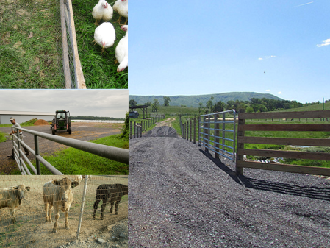  Unit Eight Landing.png
Image/Image  Attribution | 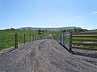  “1112” by U.S. Department of Agriculture CC BY 2.0  http://www.flickr.com/photos/usdagov/8292406140/  Rotational Grazing System.jpeg  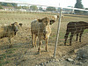  “PB220003 Fresno State Cattle are out standing in their field” by David Prasad CC BY-SA 2.0  http://www.flickr.com/photos/33671002@N00/5911766272/  CattleStanding.jpeg  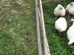  “fresh/fertilized” by Joe CC BY 2.0  http://www.flickr.com/photos/18474854@N00/2871770530/  ChickensGreen.jpeg  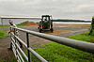  “20130712-AMS-LSC-0366.jpg” by U.S. Department of Agriculture CC BY 2.0  http://www.flickr.com/photos/usdagov/9305900466/  OpeningGate.jpeg
Content  Overview | In this unit you will apply what you have learned in this class to developing your own comprehensive pasture management plan.
Objectives | In this unit you should:  - Develop a comprehensive pasture management plan for a real or hypothetical pasture-based livestock operation.  - Develop a grazing rotation for a real or hypothetical pasture-based livestock operations.
Outcomes | - Understand the process for developing a pasture management plan and a grazing rotation plan for a pasture-based livestock operation.  - Be able to apply understanding of the processes studied within the course and develop a comprehensive pasture management plan and grazing rotation plan for a pasture-based livestock operation.
To-Do-List | 1. Read “Planning Fencing Systems for Controlled Grazing”  2. Watch the three short videos: “Winter Grazing – a Better Way to Feed,” “Winter Grazing Standing Corn with Beef Cows” and  “Farm Layout for Prescribed Grazing”  3. Complete Dropbox Assignment: “Final Project: A Pasture Management Plan”
Links/Uploads | SLF 125_Unit Eight Instructions.doc
Unit 8 Activities
Reading | “Planning Fencing Systems for Controlled Grazing”
Image/Image Attribution | 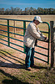  “20130307-OC-RBN-4040” by U.S. Department of Agriculture CC BY 2.0  http://www.flickr.com/photos/usdagov/8578619736/  GatedFence.jpeg
Content | Navigate to the Oregon State University Extension Douglas County site at http://extension.oregonstate.edu/douglas/ then go to the “Programs” option listed on the right hand side and choose “Livestock and Forage.” Then choose #1 “Information on Livestock and Forage production” (publications) located under the “content” heading in the middle of the main page. Choose #3 on the topic list “Pasture and Forage.” Finally click on #1 “Virginia Coop Ext” to read about planning and building fences for controlled grazing pastures.  - What categories can farm resources be divided into for a controlled grazing fencing plan?  - How can you evaluate on-farm resources to help you start a fencing layout plan?  - What are some on-farm resources you must consider as you plan a fencing layout?  - What kinds of maps will help you plan your fencing system?  - What steps should you follow to successfully implement your fencing system plans?
Links/Uploads | LINK to website: http://extension.oregonstate.edu/douglas/  LINK to article PDF: http://pubs.ext.vt.edu/442/442-130/442-130_pdf.pdf
Content Attribution | Virginia Cooperative Extension  Susan Wood Gay, Extension Engineer, Virginia Tech  S. Ray Smith, Extension Forage Specialist, Virginia Tech  Gordon E. Groover, Extension Agricultural Economist, Virginia Tech  James Donaldson, course developer
Video Assignment | “Winter Grazing and Prescribed Grazing”
Content | View the following videos on winter grazing and prescribed grazing. These videos detail how to adopt a plan for winter grazing as well as prescribed grazing.  1. “Winter Grazing – a Better Way to Feed” located at http://www.youtube.com/watch?v=PIHDmlUQ-1o  2. “Winter Grazing Standing Corn with Beef Cows” located at  http://www.youtube.com/watch?v=IJR8BOczm_Y  3. “Farm Layout for Prescribed Grazing” (NRCS – USDA website) http://www.youtube.com/watch?v=En-SaFxubFk
Content Attributions | “Winter Grazing – a Better Way to Feed” by USDA NR CS ENTSC Standard YouTube license  http://www.youtube.com/watch?v=PIHDmlUQ-1o  “Winter Grazing Standing Corn with Beef Cows” by Winter Beef Development Center (WBDC) Standard YouTube License http://www.youtube.com/watch?v=IJR8BOczm_Y  “Farm Layout for Prescribed Grazing” by NRCS – USDA Standard YouTube License  http://www.youtube.com/watch?v=En-SaFxubFk  James Donaldson, course developer
Dropbox Assignment | “Final Project: A Pasture Management Plan”
Content | Using the rough outline that you created last week for the Discussion Post, feedback you received from classmates and all course materials we have studied during the semester follow the directions listed in the Final Project Assignment Sheet to successfully complete the final project for this class. This project is worth 125 points.  Please Note: You will need to specifically use the “Determining Your Stocking Rate” reading from Unit Five to answer number four on the Final Project Assignment sheet. This reading is attached as a link for you to reference.
Links/Uploads | Final Project Assignment Sheet.doc  “Determining Your Stocking Rate” reading from Unit Five https://extension.usu.edu/htm/publications/publication=6247  Use this reading to answer question four of the final project assignment sheet.
Content  Attribution | James Donaldson, course developer

